**Android Assignment 3 (of 5)**

* Extending the functionality from Assignment 2. The next task is to create and application that looks similar to that shown below.

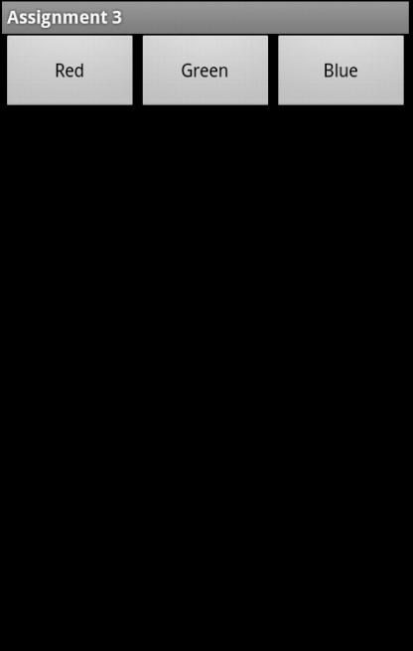

* The three buttons are aligned horizontally at the top of the screen. When one of the keys is pressed the background colour is changed to the corresponding colour marked on the key as shown below.

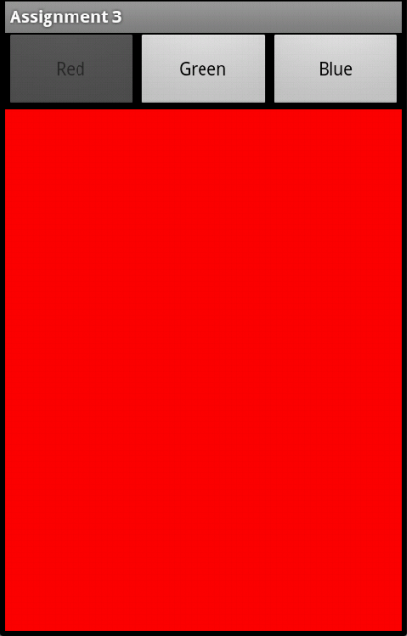

* This should work in a similar way for all **three** colours.
* As an **extra** task, add extra code to grey out the active button. For example, if the background is currently red, then the red button should not be available for selection. This applies to each of the three colours.
* For those that finish all of the above tasks, adapt your program to include an options menu that allows the colour selection to be made from a menu instead of the buttons. Your program should then look something like this:

